13)Function overloading

using namespace std;

#include<iostream>

void change(int data);

int main()

{

int data=3;

change(data);

return 0;

}

void change(int data)

{

data=5;

cout<<data;

}

Output:

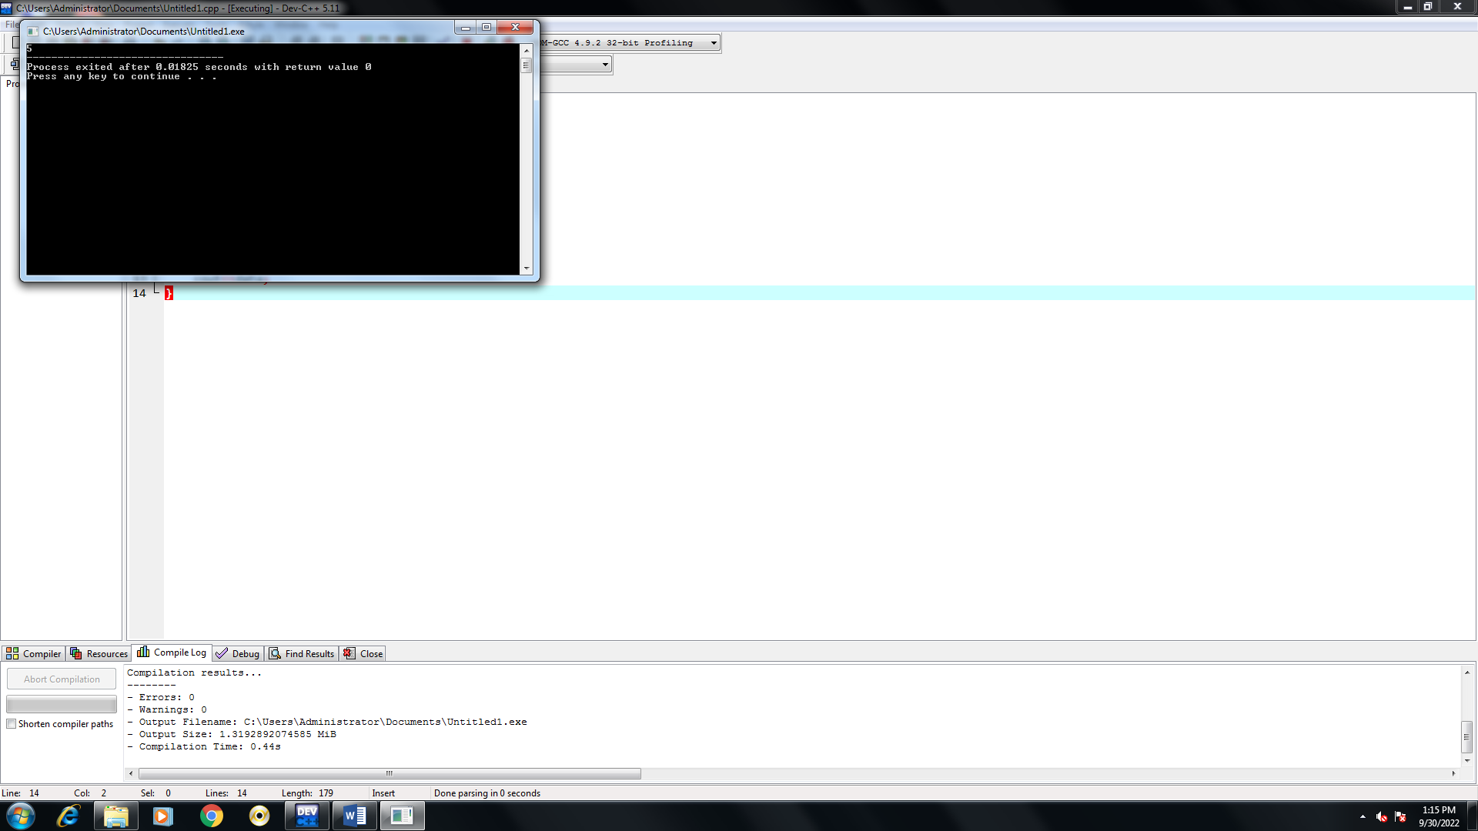

17)Read a class addamount with datamember is amount with initial value is rupees 50 now make two constructors.One having no parameter(no amount added).Two having parameter (amount added).Create an object for addamount class display final amount.

using namespace std;

#include<iostream>

class addamount

{

float amount,b;

public:

addamount();

addamount(float);

void display();

};

addamount::addamount()

{

amount=50;

}

addamount::addamount(float x)

{

amount=x;

}

void addamount::display()

{

cout<<"amount"<<amount;

b=50+amount;

cout<<"b"<<b;

}

int main()

{

addamount a(30);

a.display();

return 0;

}

Output:

